DATE:14-03-2024

EASY PROGRAMS:

1.Write a C++ program with a main function that prints "Hello, World!" to the console.

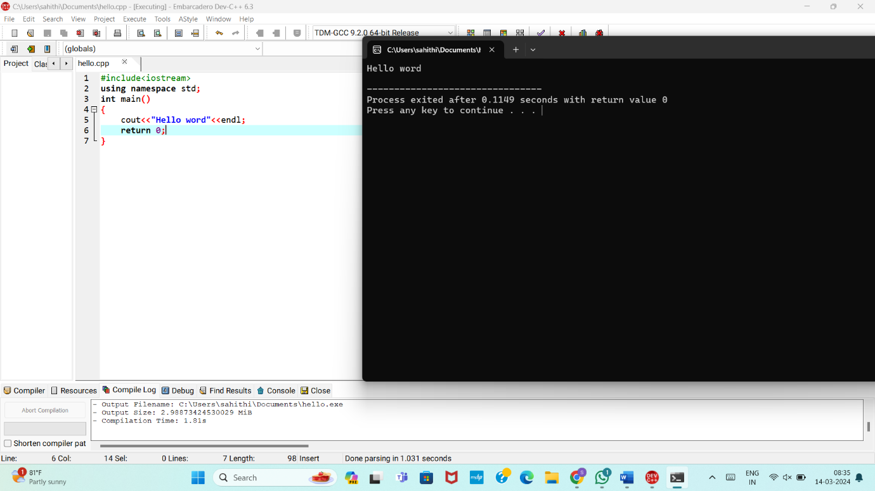

2. Create a C++ program with a function prototype for a function named **addNumbers** that takes two integers as parameters and returns their sum. Implement the function below the main function and use it to add two numbers.

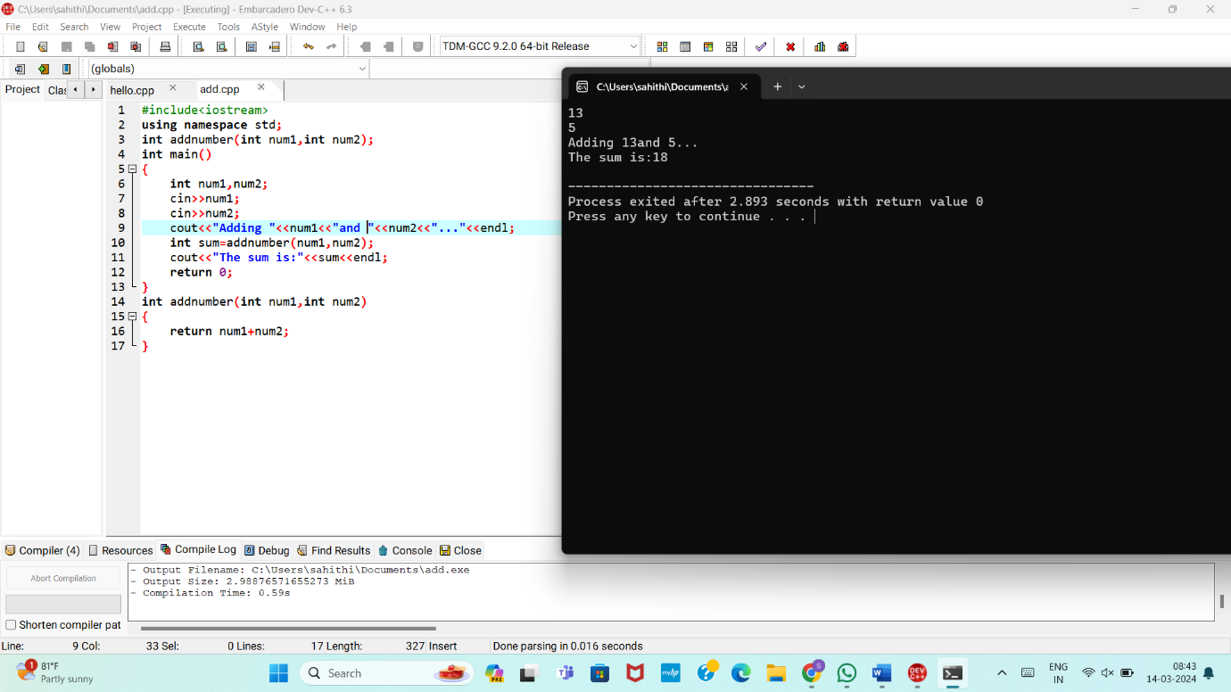

3. Write a C++ program that demonstrates call by reference by swapping the values of two variables.

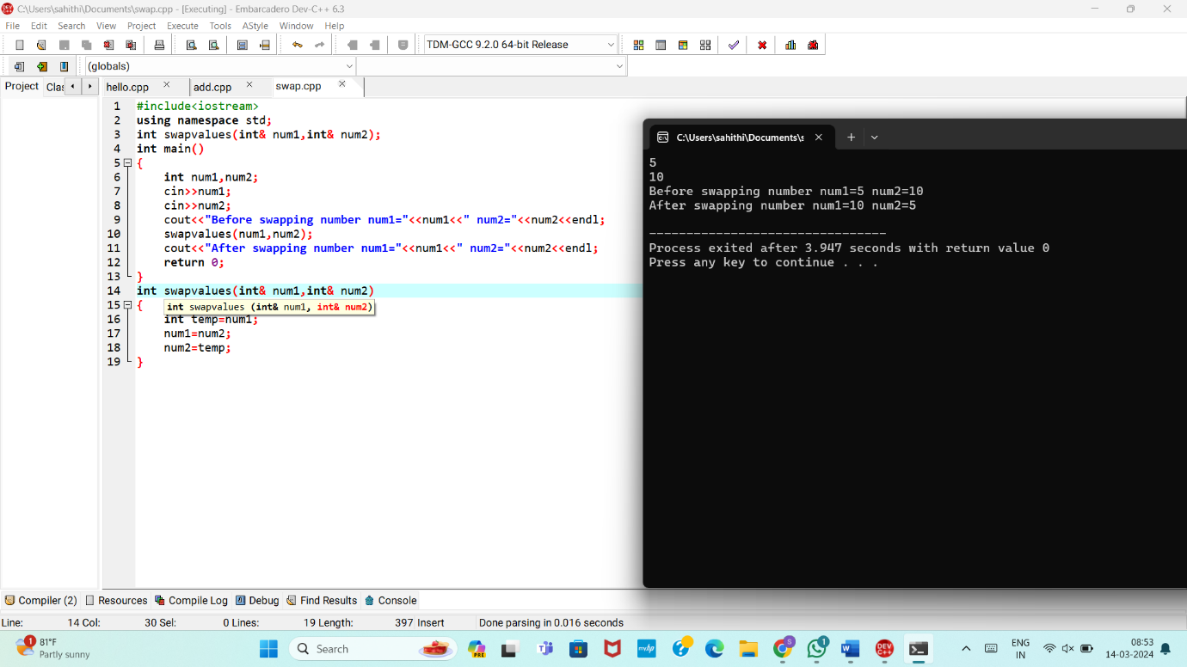

4. Develop a C++ program with a function that returns a reference to an integer variable and modifies its value. Use this function to update the value of a variable in the main function.

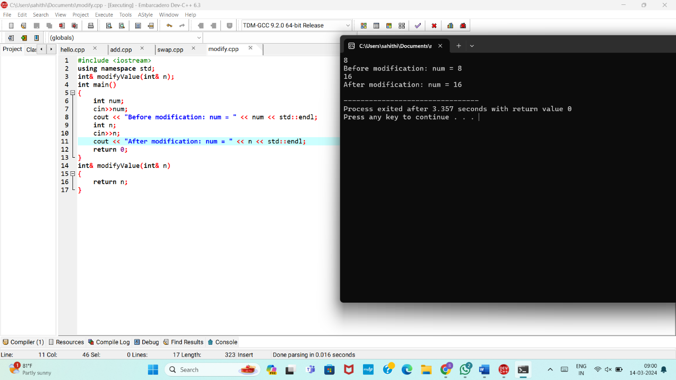

5. Implement an inline function named **square** that calculates the square of a number. Use this function to square a user-input integer.

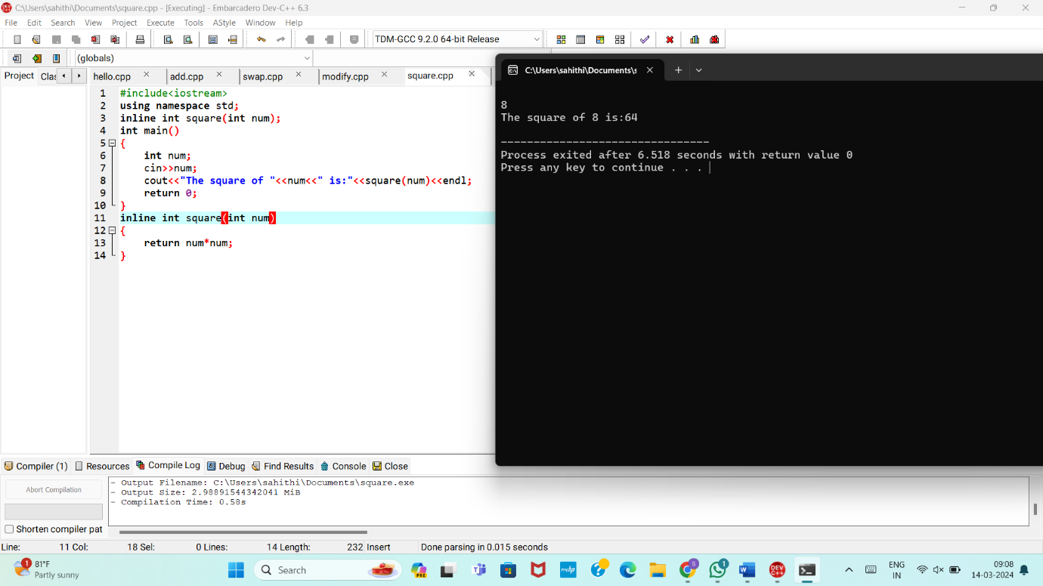

6. Write a C++ program that defines a function named **printMessage** with a default argument "Hello". Call this function without passing any argument.

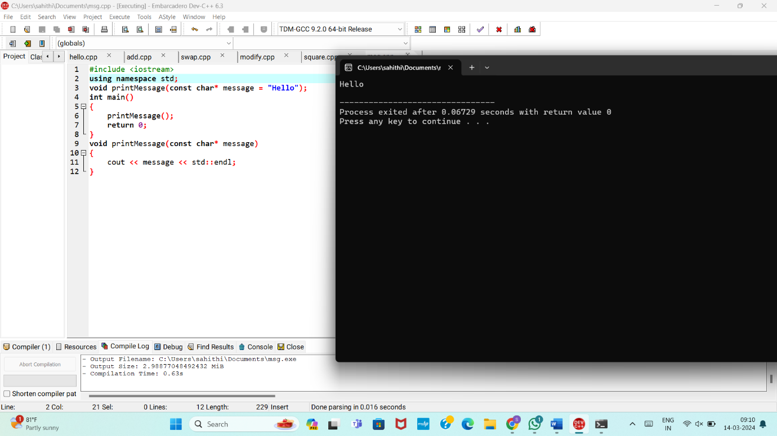

7. Create a C++ program with two overloaded functions named **area** - one to calculate the area of a rectangle (length * width) and another to calculate the area of a circle (π * radius^2). Use function overloading to determine which function to call based on the number of arguments.

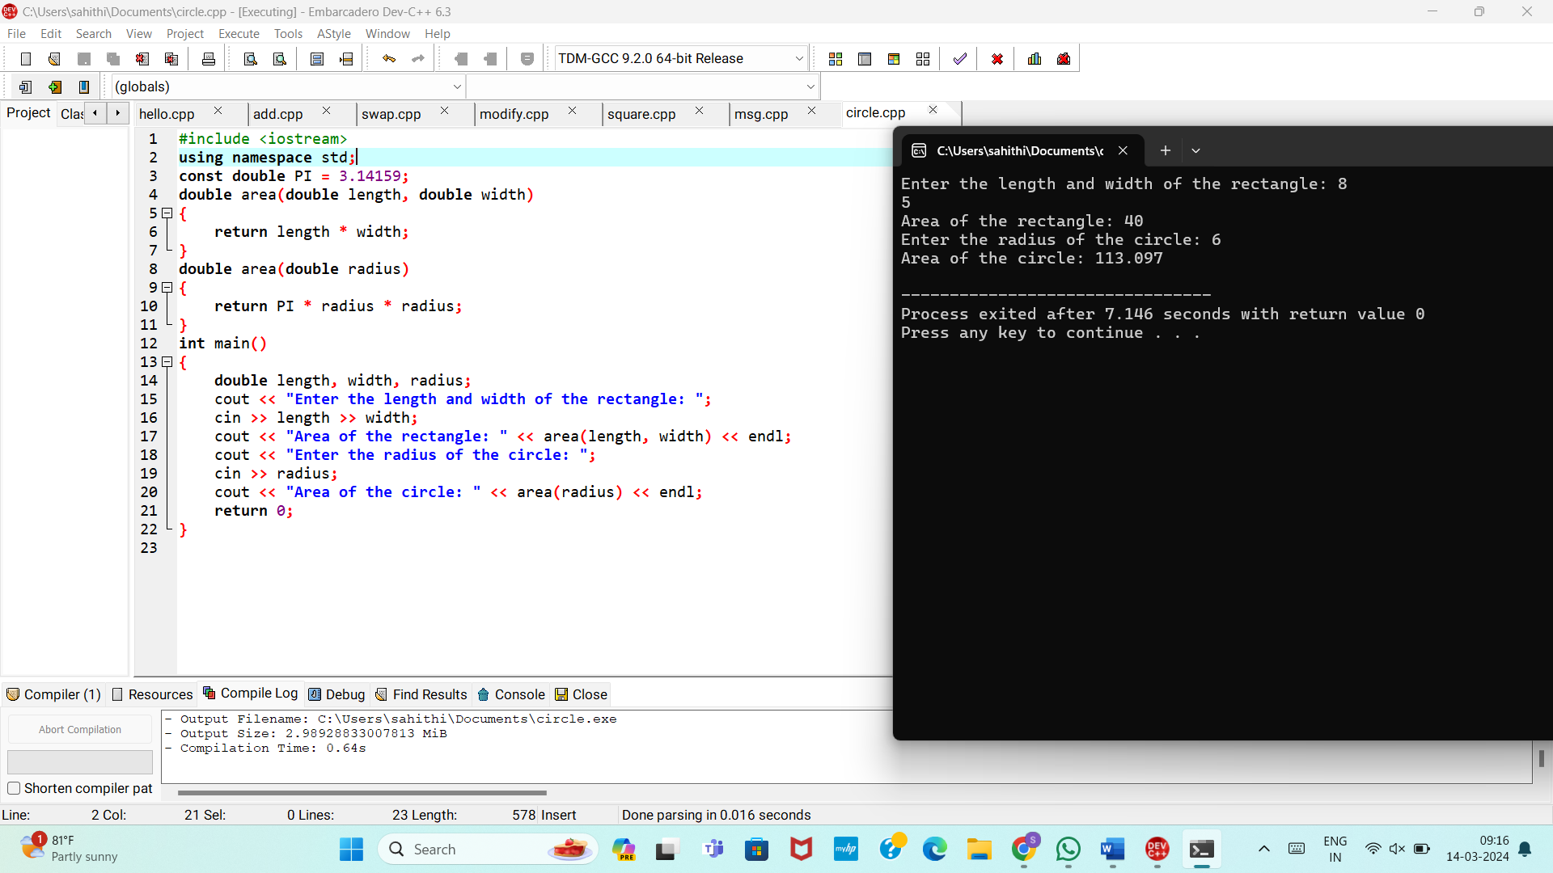

8. Define a C++ class named **Rectangle** with private member variables **length** and **width**. Implement public member functions to set and get the length and width of the rectangle.

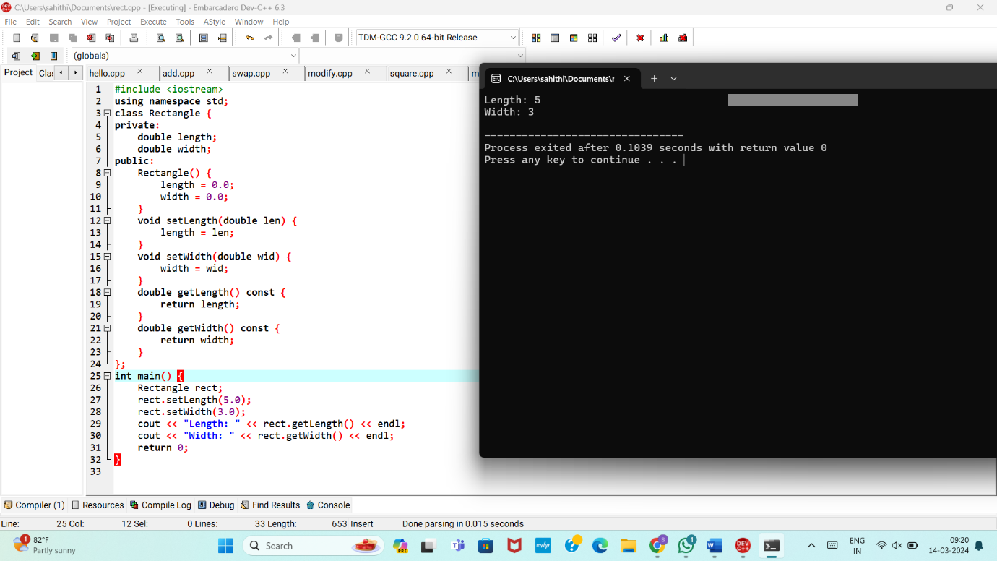

9. Extend the **Rectangle** class to include an array of integers named **coordinates** to store the (x, y) coordinates of the rectangle. Implement member functions to set and get the coordinates.

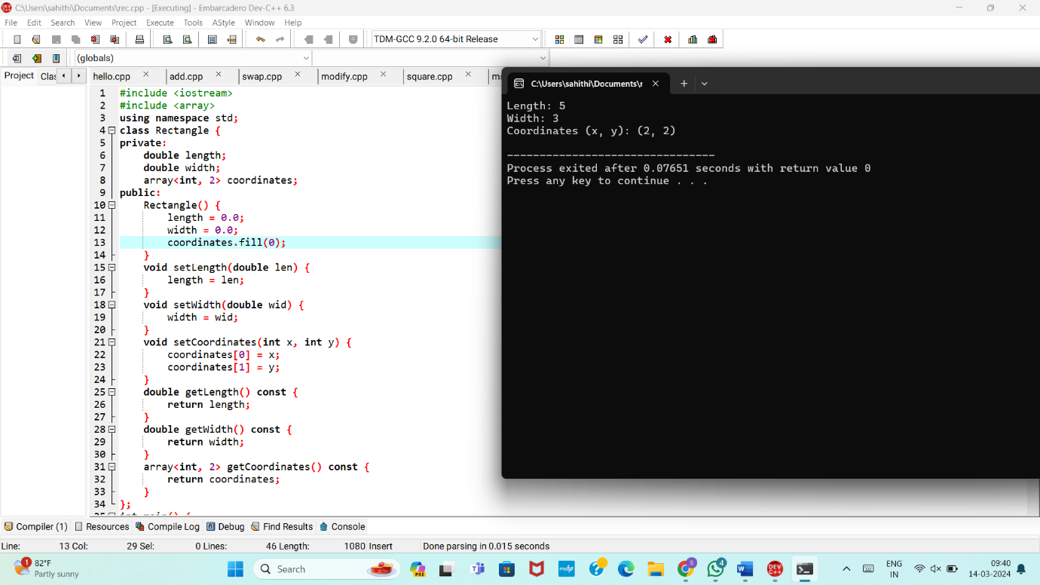

10. Add a static member function named **countRectangles** to the **Rectangle** class that keeps track of the total number of rectangle objects created. Display the count in the main function.

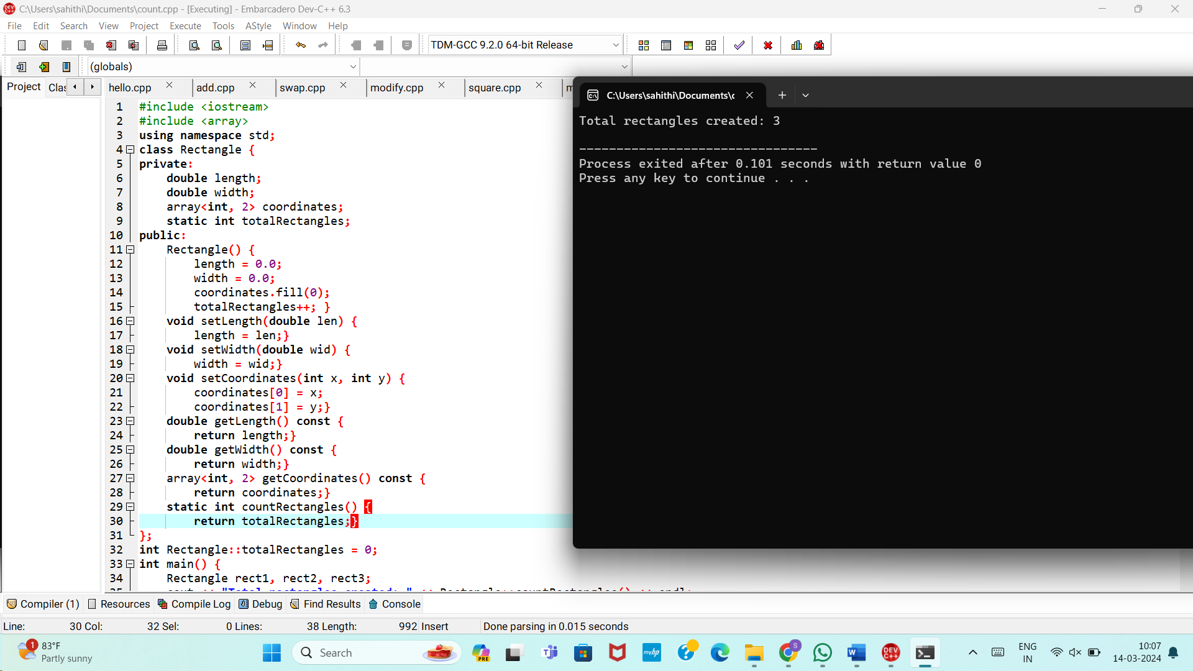

MEDIUM PROGRAMS:

1.Write a C++ program that calculates the volume of a cube, rectangle, or cylinder based on user choice. Use function prototypes and function overloading to define separate functions for each shape's volume calculation.

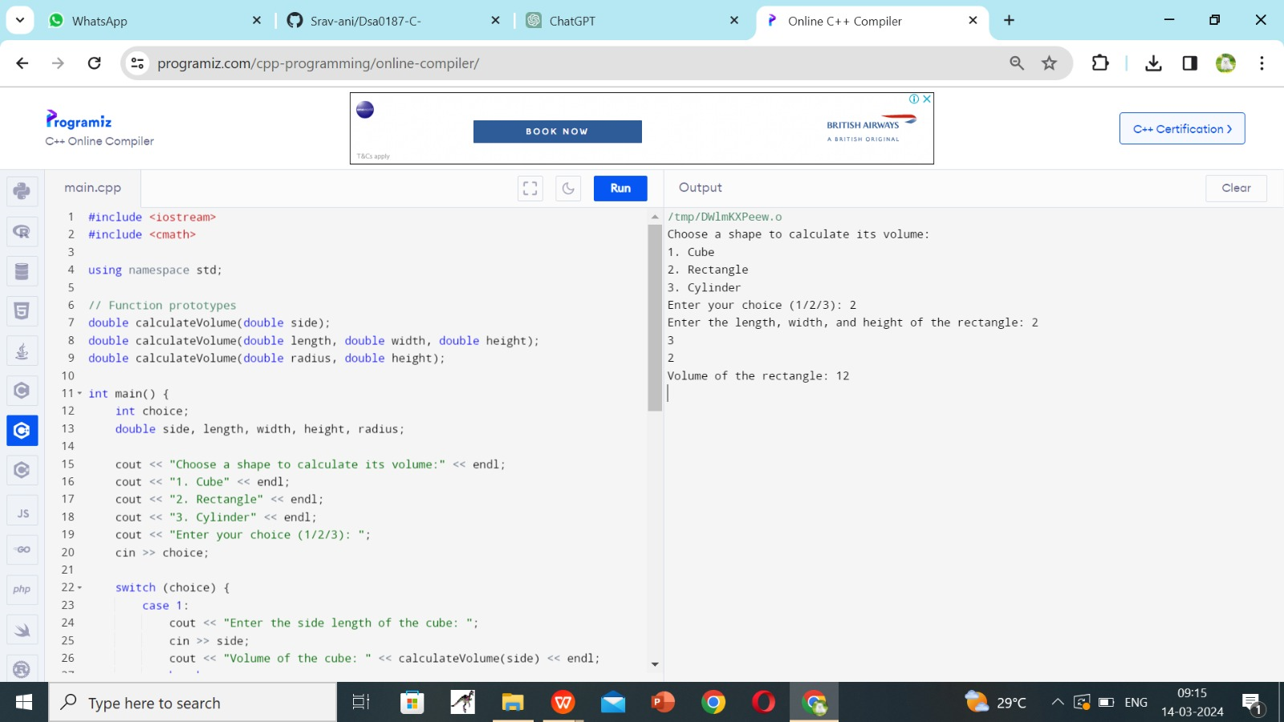

2. Define a class named **Student** with private member variables **name**, **id**, and an array **grades** to store the student's grades in three subjects. Implement member functions to set and get the student details and grades.

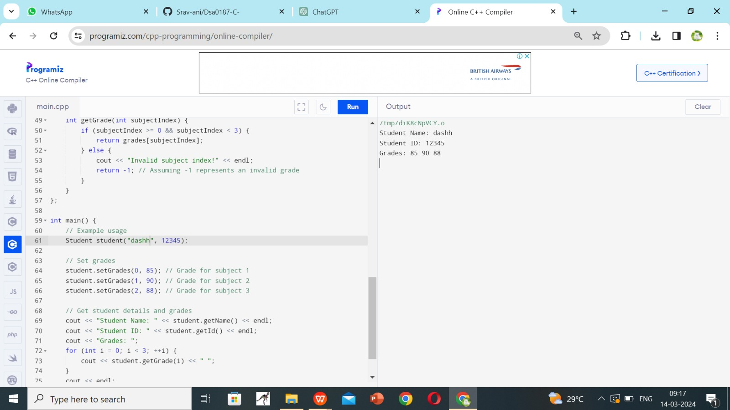

3. Create a C++ program that defines an inline function named **calculateArea** to calculate the area of a rectangle. Provide default arguments for length and width parameters. Use this function to calculate the area of a rectangle with user-input dimensions.

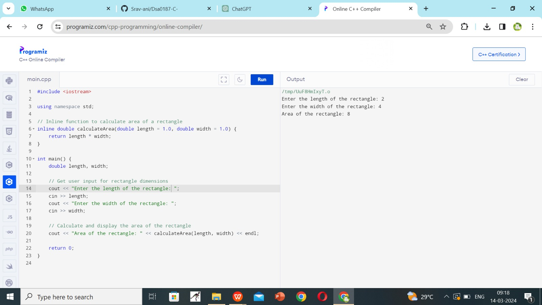

4. Define a class named **Employee** with private member variables **name** and **salary**. Implement a static member function to calculate the average salary of an array of **Employee** objects.

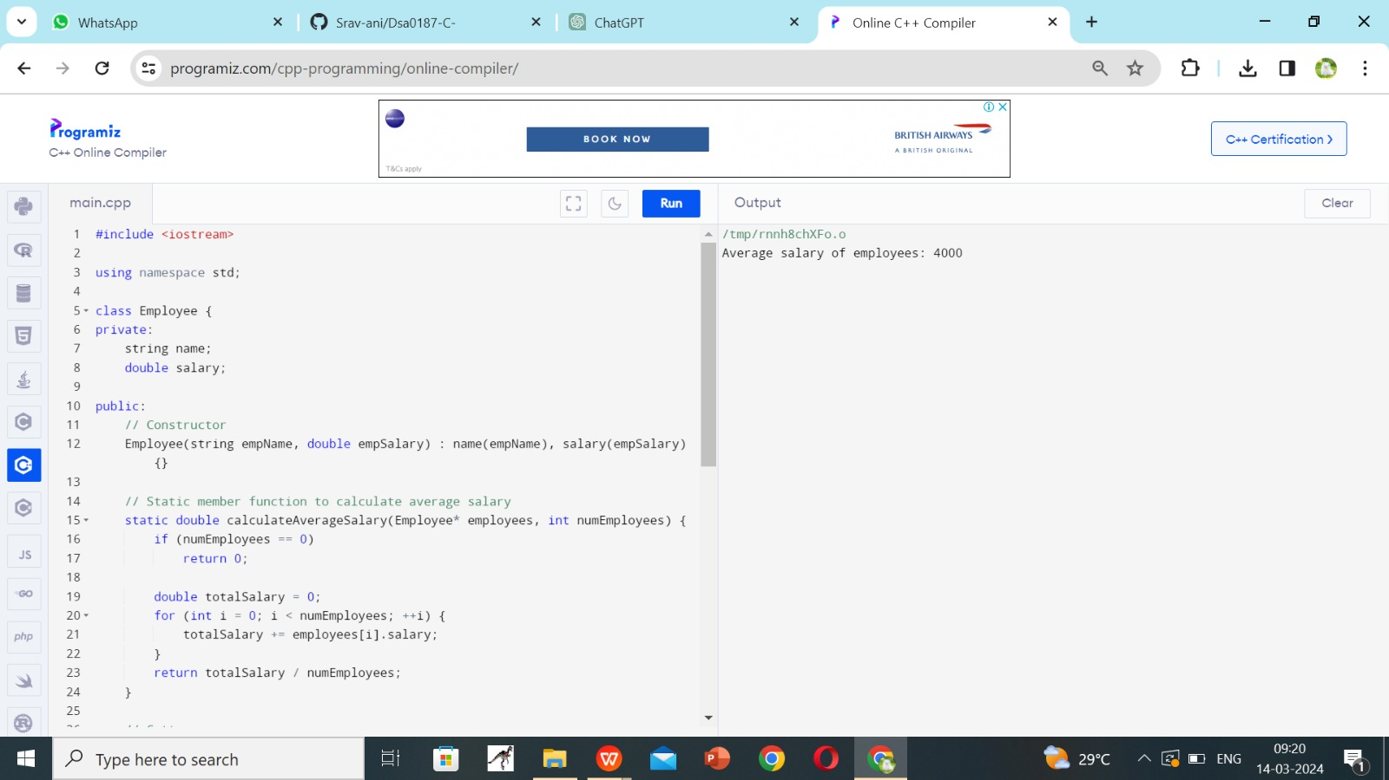

5. Define two classes, **Complex** and **Matrix**. Make **Matrix** a friend of **Complex**. Implement a function in **Matrix** class that multiplies a **Complex** number with a constant and returns the result by reference.

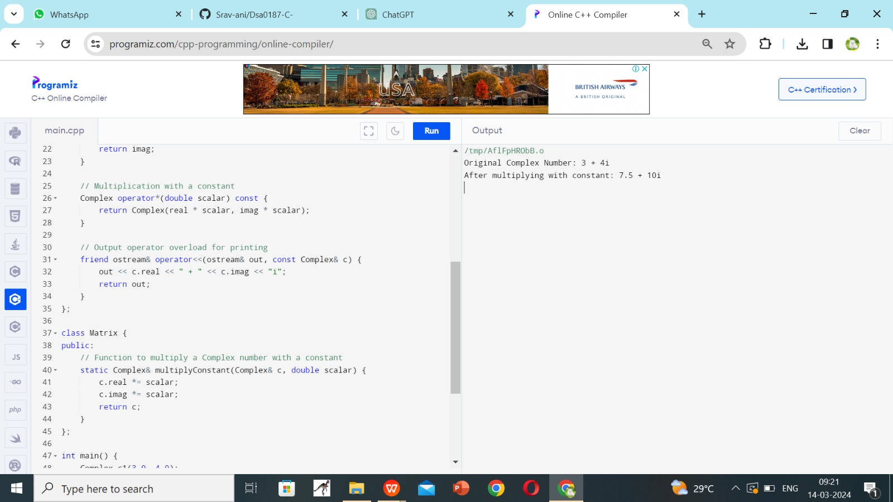

6. Write a C++ program that contains overloaded functions named **swap**. Define one version that swaps two integers and another version that swaps two arrays of integers. Implement these functions using call by reference.

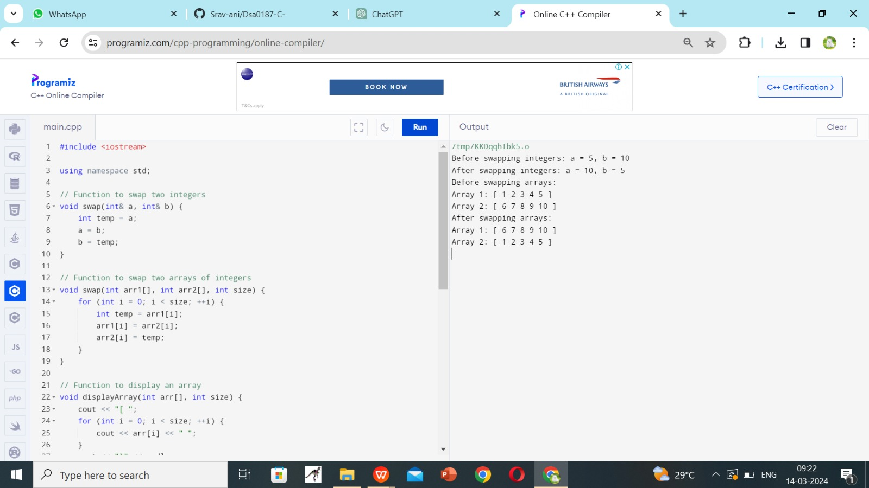

7. Define a class named **Circle** with private member variables **radius** and **area**. Implement member functions to set the radius, calculate the area, and display the circle's details.

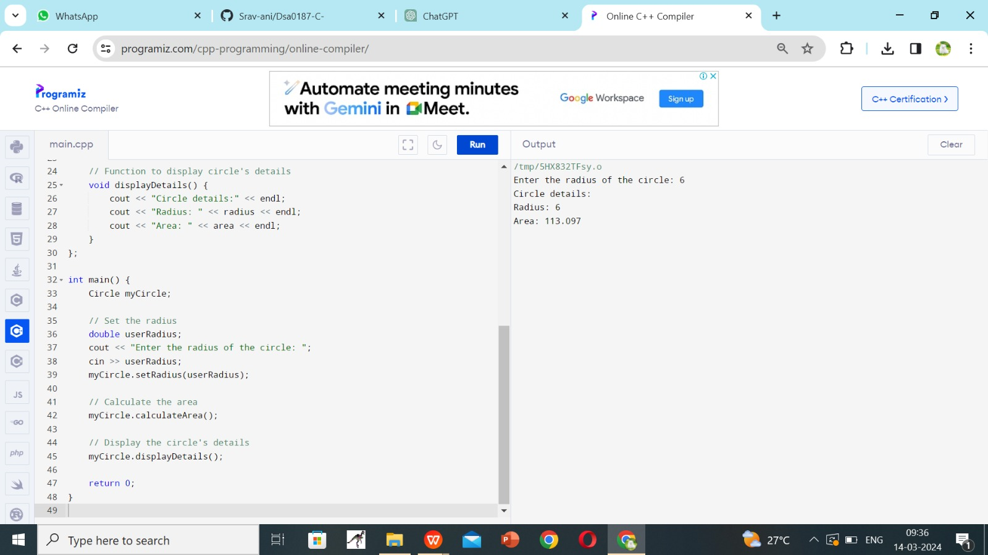

8. Create a C++ program that defines a class named **Car** with private member variables **model**, **year**, and **price**. Implement an array of **Car** objects and provide default values for **year** and **price**.

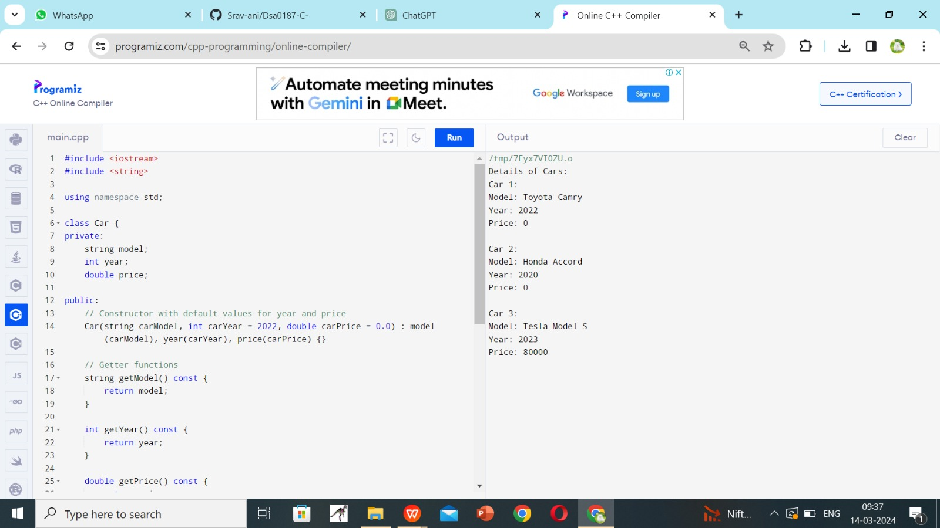

9. Define a C++ function named **largestElement** that returns a reference to the largest element in an array of integers. Use this function to find the largest element in a user-input array.

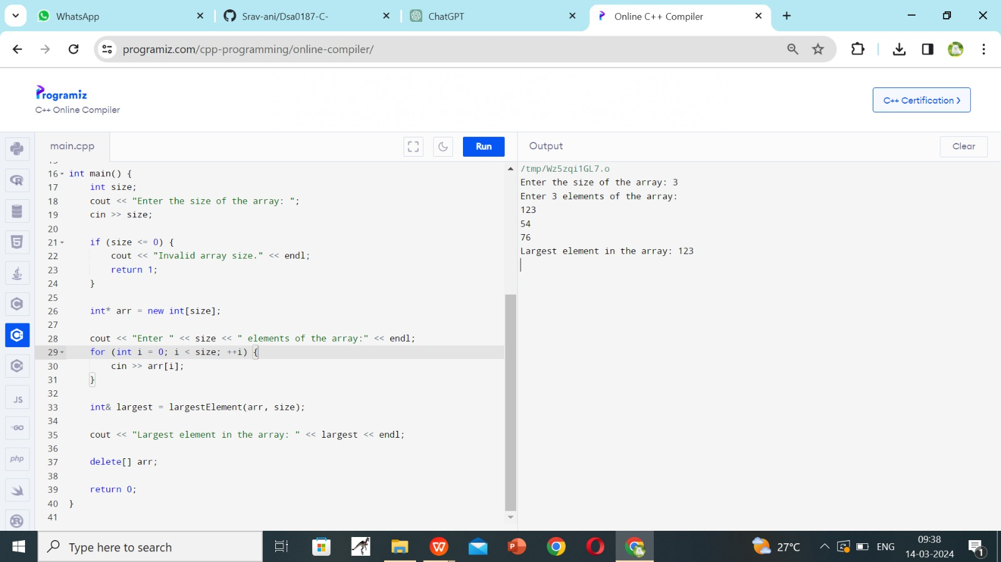

10. Write a C++ program with function prototypes for calculating the area and perimeter r of a rectangle. Implement these functions with default arguments for length and width. Prompt the user to enter the length and width to calculate the area and perimeter.

